**Reference No:** C05…..

**Damage Report Date:** .07/12/12...

**Incidents must be reported immediately.**

Damage found in Container must not to be touched until pictures have been taken to effectively demonstrate to stake holders how damage could have arised?

In Container Container No:

In Warehouse How was it damaged? Forklift crushing

Product…P7000S–Serial No. ACSP01013……………….. Qty………1 box………

*Insert* Picture:

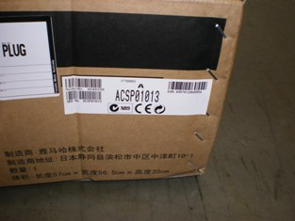

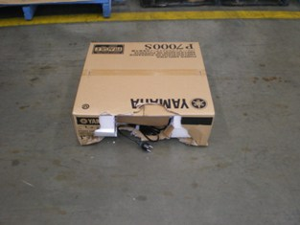

Reported by…Frank Vastag…………………………………………………………………….